WEEK 5-Microservices-Hands On-Exercise

Creating Microservices for account and loan

Account Microservice:

Created a folder with id 6137524.
Created subfolder named 'microservices' inside the 6137524.
Opened https://start.spring.io/ in browser and entered the following values:
Group: com.cognizant
Artifact: account
Selected the following dependencies:
→Spring Boot DevTools
→Spring Web
Clicked on generate and downloaded the zip file.
Extracted 'account' folder from the zip and placed it inside the
'microservices' folder.
Opened command prompt in account folder and ran the mvn clean
package command.
Imported the project into Eclipse and implemented a controller method for getting account details based on account number.

AccountController.java

package com.cognizant.account;
import org.springframework.web.bind.annotation.*;
import java.util.Map;
@RestController
@RequestMapping("/accounts")
public class AccountController {
@GetMapping("/{number}")
public Map<String, Object> getAccount(@PathVariable String number) {
return Map.of(
"number", number,
"type", "savings",
"balance", 234343
);
}
}

Tested in Postman:
Port used : 8080
Method : GET
Url : http://localhost:8080/accounts/00987987973432

OUTPUT:

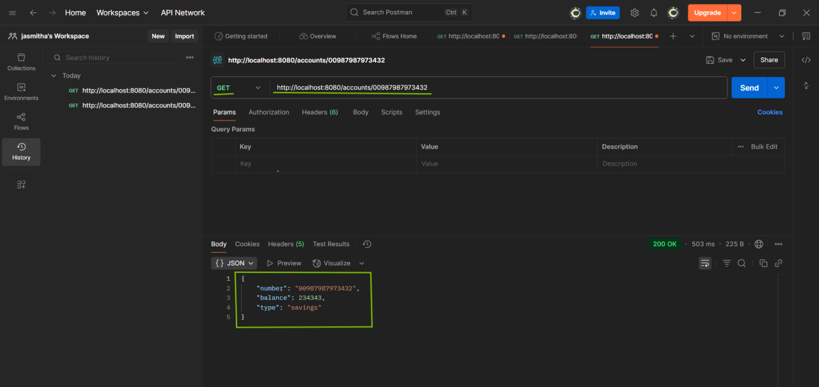

Console:

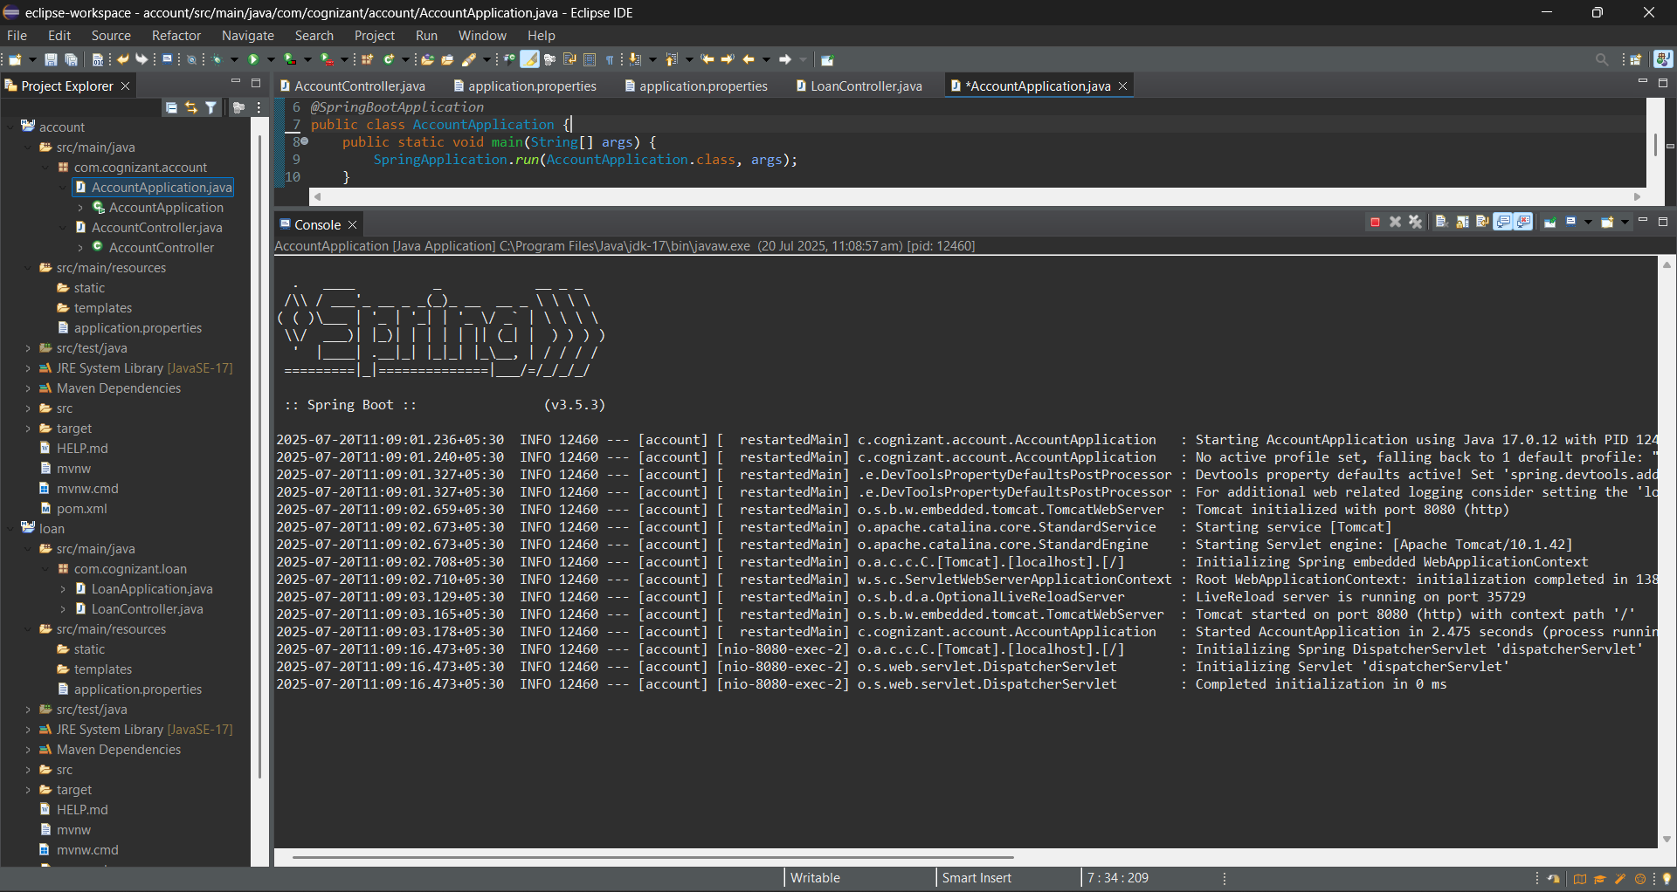

Loan Microservice:

Opened https://start.spring.io/ in browser and entered the following values:
Group: com.cognizant
Artifact: loan
Selected the following dependencies:
→Spring Boot DevTools
→Spring Web
Clicked on generate and downloaded the zip file.
Extracted 'loan' folder from the zip and placed it inside the
'microservices' folder.
Imported the project into Eclipse

LoanController.java

package com.cognizant.loan;
import org.springframework.web.bind.annotation.*;
import java.util.Map;
@RestController
@RequestMapping("/loans")
public class LoanController {
@GetMapping("/{number}")
public Map<String, Object> getLoan(@PathVariable String number) {
return Map.of(
"number", number,
"type", "car",
"loan", 400000,
"emi", 3258,
"tenure", 18
);
}
}

Tested in Postman:
Port used : 8081
Method : GET
Url : http://localhost:8081/loans/H00987987972342

OUTPUT:

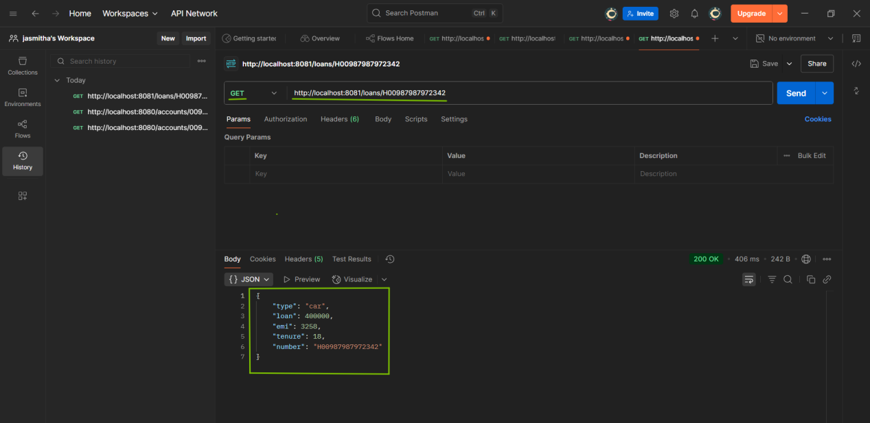

Console:

